HEALTH CARE DATA VISUALIZATION
COST RELATIONSHIP AND POLICY INSIGHTS
Name: SOORYA SV
Registration No.: 26BSC100
RegistrationA Data Analysis Report26BSC087

Course:B.Sc.CS(AI&DS)

ToolUsed:GoogleColab
Dataset: Healthcare dataset (55,500 initial records)

HEALTHCARE DATA VISUALIZATION

1

Executive Summary
This report analyses a healthcare admissions dataset using Python in Google Colab. The notebook starts with 55,500 rows and 15 fields; 534 duplicate rows were removed, leaving 54,966 records for analysis. No missing values were reported. Visualizations examine patient age and condition mix, billing amounts, monthly admission volume, and relationships among age, billing, and length of stay.
The strongest quantitative result is that the Pearson correlations among Age, Billing Amount, and Length of Stay are all close to zero (r = −0.0034, 0.0079, and −0.0049 respectively). Thus, this dataset does not show a meaningful linear relationship between age and bill, or between length of stay and bill. Negative billing values and the absence of currency/unit metadata require validation before financial or policy decisions.

Contents
•1. Objective
•2. Dataset overview and preparation
•3. Patient demographics analysis
•4. Billing analysis
•5. Temporal admission trend analysis
•6. Cost relationship and correlation analysis
•7. Key findings
•8. Healthcare management recommendations
•9. Conclusion
•Appendix: chart and interpretation notes

1. Objective
The objective is to use descriptive statistics and visualizations to understand who is represented in the healthcare records, how billing amounts vary, whether admission volume changes by calendar month, and whether age or length of stay is associated with billing. The report also translates the observed patterns into practical, cautious recommendations for operational planning and billing review.

2. Dataset overview and preparation

The uploaded notebook loads healthcare_dataset.csv into a Pandas DataFrame. It includes 15 columns covering patient attributes, diagnoses, admission/discharge dates, provider and hospital, insurance, billing amount, admission type, medication, and test results. The notebook reports 55,500 rows before cleaning and removes 534 duplicate rows, giving 54,966 distinct rows for subsequent analysis. It reports zero missing values in every field.
 | Item |  | Notebook result
 | Initial size |  | 55,500 records × 15 columns
 | Duplicate records removed |  | 534
 | Rows after duplicate removal |  | 54,966
 | HEALTHCARE DATA VISUALIZATION |
 | Item | Notebook result
 | Missing values | 0 in all 15 fields
 | Admission and discharge dates | Converted to datetime
 | Billing Amount mean / median | 25,544.31 / 25,542.75 (dataset units)
 | Billing Amount range | −2,008.49 to 52,764.28 (dataset units)
 | Age mean / range | 51.54 years / 13–89 years
Age groups were defined in the notebook as Child (0–17), Young Adults (18–39), Middle Adults (40–59), and Senior (60+). “Length of Stay” was calculated as discharge date minus admission date, measured in days. The notebook does not document the billing currency or whether the records are real, synthetic, or de-identified; this report therefore calls the amounts “dataset units” and treats the findings as descriptive rather than causal.
Important data-quality note: the minimum billing amount is negative (−2,008.49). A negative amount may reflect a credit, adjustment, refund, or data error, but the notebook does not distinguish these explanations. Validate these records before interpreting averages or setting budgets. Also, the notebook creates monthly totals by month number across all years, so these figures show seasonality-like month aggregation, not a year-byyear trend.
3. Patient demographics analysis
3

Age profile
Seniors form the largest age group: 20,948 records (about 38.1%). Young adults contribute 17,594 (32.0%), middle adults 16,308 (29.7%), and children 116 (0.2%). The average age is 51.54 years and the median age is 52. The age distribution suggests that the dataset is predominantly adult, with the largest single group aged 60 and above.
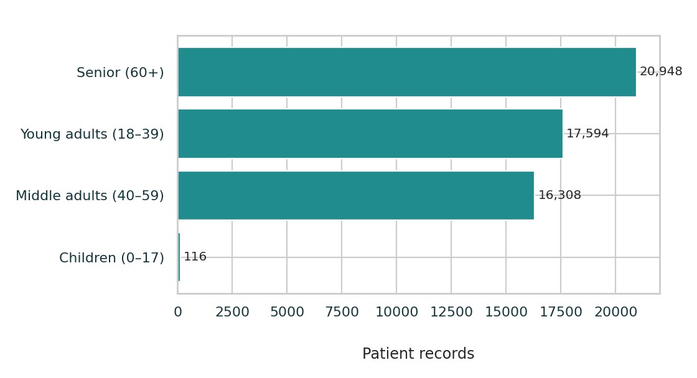
Figure 1. Distribution of records by the notebook age-group definitions.

Medical-condition profile
HEALTHCARE DATA VISUALIZATION |
The six listed conditions have closely similar record counts, each between 9,095 and 9,218. Arthritis is highest at 9,218; Asthma is lowest at 9,095. Because the spread is small, no single condition dominates this dataset. These counts describe the dataset’s category distribution and should not be treated as population prevalence.

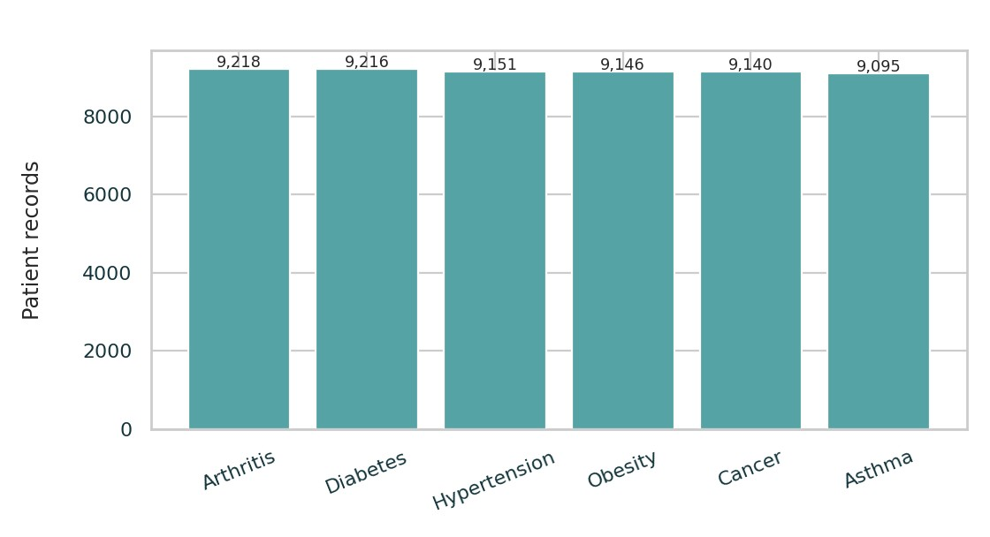
Figure 2. Record counts by medical condition.

Gender visualization
The notebook includes a gender count plot, but the saved notebook outputs do not expose the underlying category counts as text. Accordingly, this report does not invent male/female percentages. The chart is available in the source notebook and can be used to confirm the split when the notebook is rerun.
HEALTHCARE DATA VISUALIZATION |
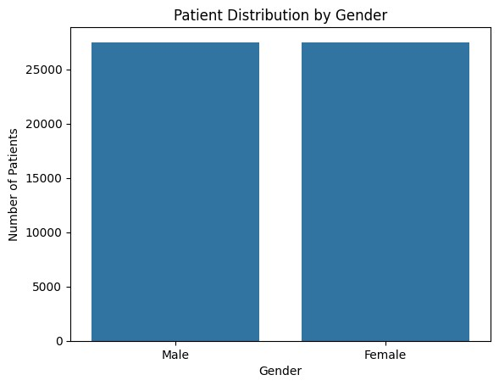
Figure 3. Gender count plot from the submitted Google Colab notebook.
Observation: the age-group and condition counts are sufficiently balanced for descriptive comparison, but a demographic chart alone cannot explain disease burden, clinical severity, or differences in access to care. Those questions require additional stratification and data context.

4. Billing analysis
Billing Amount has a mean of 25,544.31 and median of 25,542.75 dataset units, with a standard deviation of 14,208.41. The 25th percentile is 13,243.72 and the 75th percentile is 37,819.86, so the middle half of records spans a broad interval of roughly 24,576 units. The maximum is 52,764.28; the minimum is a negative value, which merits reconciliation.

Billing visualization 1: distribution
HEALTHCARE DATA VISUALIZATION |
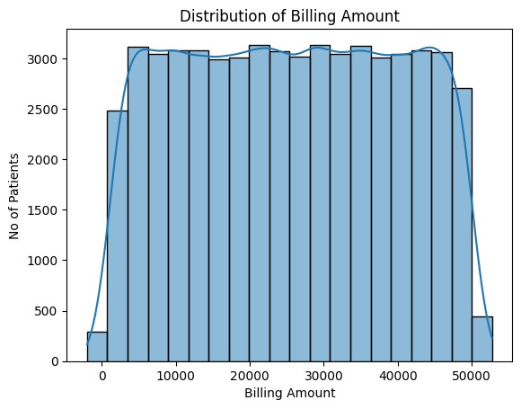
Figure 4. Billing amount distribution and KDE curve from the notebook.
Observation: the chart shows substantial spread in patient-level charges. The mean and median are very close, but that does not remove the need to inspect the negative record and extreme values. Because the source output does not preserve plotted bin counts, no unsupported claim is made about a precise skew or mode.

Billing visualization 2: insurance provider
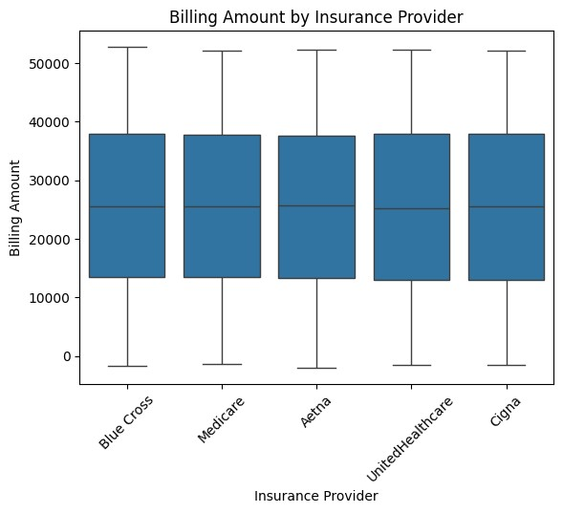
Figure 5. Billing amount by insurance provider (box plot).
Observation: use this box plot to compare medians, interquartile ranges, and outliers across insurers. The notebook output does not include the numerical group medians or quartiles, so this report does not claim that one insurer is more expensive. Insurance enrolment counts are relatively close: Cigna 11,139; Medicare 11,039; UnitedHealthcare 11,014; Blue Cross 10,952; and Aetna 10,822.
HEALTHCARE DATA VISUALIZATION |

Billing visualization 3: admission type
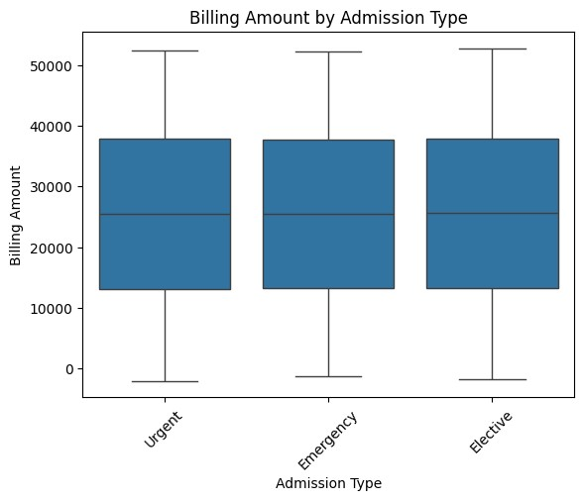
Figure 6. Billing amount by admission type (box plot).
Observation: the plot supports a visual comparison of Elective, Urgent, and Emergency bills. Their record counts are also similar: Elective 18,473, Urgent 18,391, and Emergency 18,102. Admission urgency should not be interpreted as the cause of a higher or lower bill without adjustment for diagnosis, treatment, length of stay, and other case-mix factors.

Additional diagnosis view
HEALTHCARE DATA VISUALIZATION |
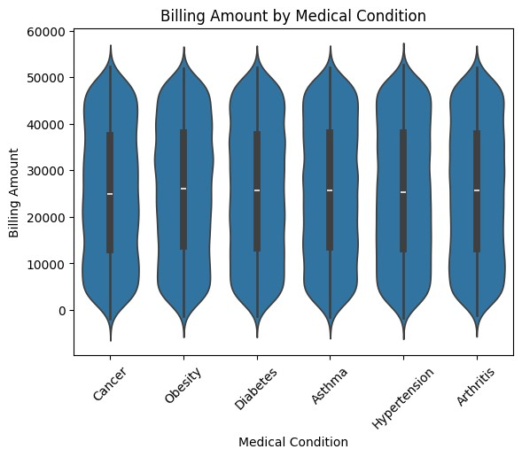
Figure 7. Billing amount by medical condition (violin plot) from the notebook.
This additional plot can help identify differences in billing distributions by condition. The report does not state a ranking because the notebook output does not include computed category-level billing statistics.

5. Temporal admission trend analysis
Admissions were grouped by calendar month number across all years included in the dataset. The monthly counts are: January 4,655; February 4,210; March 4,622; April 4,478; May 4,555; June 4,650; July 4,765; August 4,785; September 4,508; October 4,613; November 4,508; and December 4,617.
HEALTHCARE DATA VISUALIZATION |
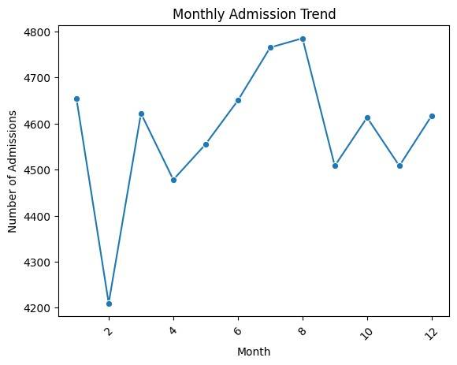
Figure 8. Monthly admissions aggregated across all years, as shown in the notebook.
Observation: August has the highest total (4,785), while February has the lowest (4,210), a difference of 575 records. The range is modest relative to monthly totals. Since year is not separated in this plot, it cannot establish a trend over time or explain whether a particular year drove a peak. The notebook also plots admission types by month; it can support a check of whether each admission category has similar monthly patterns.
HEALTHCARE DATA VISUALIZATION |

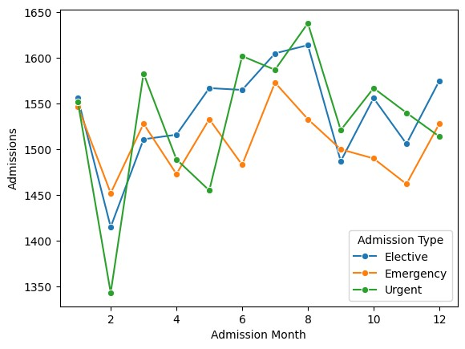
Figure 9. Monthly admissions by admission type from the notebook.
For operational forecasting, the stronger next step is a year-month time series, with separate counts by admission type, hospital, and clinical service. That avoids combining several years into a single seasonal profile.
6. Cost relationship and correlation analysis
The notebook calculates Pearson correlation coefficients for Age, Billing Amount, and Length of Stay (days). Pearson r summarizes linear association, ranges from −1 to +1, and values near zero indicate little linear association in these observed data. The results are:
 | Variable pair | Pearson r | Interpretation
 | Age – Billing Amount | −0.0034 | Essentially no linear association in this dataset.
 | Age – Length of Stay | 0.0079 | Essentially no linear association in this dataset.
 | Billing Amount – Length of Stay | −0.0049 | Essentially no linear association in this dataset.
Age vs billing amount
HEALTHCARE DATA VISUALIZATION |
12

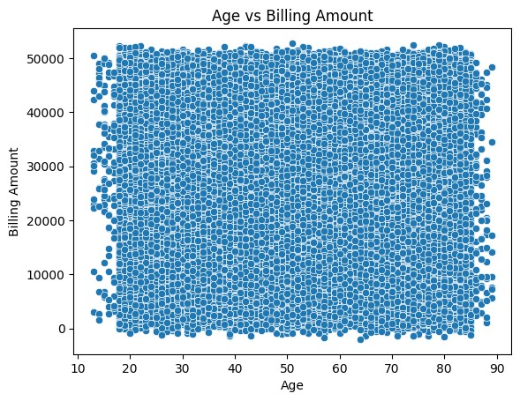
Figure 10. Age versus billing amount scatter plot from the notebook.
Observation: the scatter plot is consistent with the near-zero correlation (r = −0.0034); age alone does not explain billing variation in this dataset. This is not evidence that age never matters clinically: it means a linear relationship is not visible in this particular dataset using these variables and this analysis.

Length of stay vs billing amount
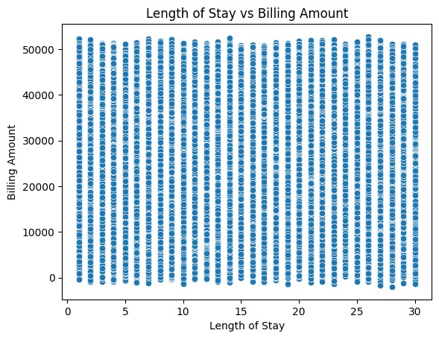
Figure 11. Length of stay versus billing amount scatter plot from the notebook.
Observation: the correlation is −0.0049, also effectively zero. This is an unusual operational pattern if bills are expected to accumulate with days of care, and deserves investigation of how billing and length of stay were generated, whether charges are package-based, and whether the data are synthetic or contain independent random fields. Do not infer that reducing stay length will not affect costs from this result alone.

Correlation heat map
HEALTHCARE DATA VISUALIZATION |
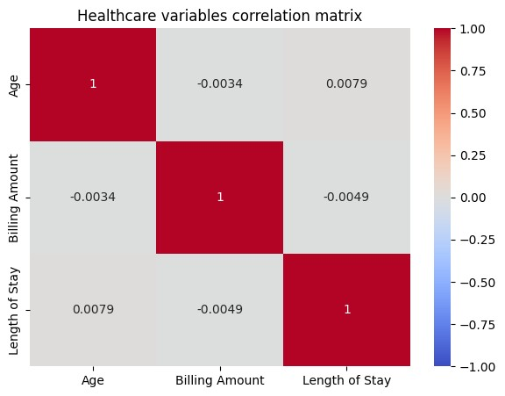
Figure 12. Correlation heat map for age, billing amount, and length of stay.
The heat map confirms that all off-diagonal coefficients are close to zero. Correlation is not causation, and Pearson correlation can miss nonlinear relationships or interactions. A stronger cost model would use diagnosis, treatment intensity, admission type, hospital, insurer, and other validated variables, along with data-quality checks.

7. Key findings
1.After removing 534 duplicates, 54,966 records remained; the notebook reported no missing values across the 15 original fields.
2.The dataset is adult-heavy: seniors comprise 20,948 records (about 38.1%), compared with only 116 children (about 0.2%).
3.The six medical-condition categories are nearly evenly represented, ranging from 9,095 Asthma records to 9,218 Arthritis records.
4.Monthly admissions aggregated over all years peak in August (4,785) and are lowest in February (4,210); this is a combined month-of-year view, not a year-to-year trend.
5.Age, billing amount, and length of stay have near-zero pairwise linear correlations (r from −0.0049 to 0.0079); age and stay length alone do not explain billing variation here.
6.Billing ranges from −2,008.49 to 52,764.28 dataset units; the negative amount and unreported currency/unit need to be resolved before financial interpretation.
HEALTHCARE DATA VISUALIZATION |

8. Healthcare management recommendations 1. Plan capacity using validated demand patterns
Use the month-of-year counts as an initial planning signal only. First build a date-level table by year and month, then review rolling admission volumes by admission type, hospital, and service line. If the August pattern persists across years, use it to test staffing, bed, and supply scenarios; avoid staffing changes based solely on the pooled 12-month chart.

2. Establish a billing-quality and variance review
Reconcile negative amounts against credit notes, refunds, and adjustments; confirm the billing currency and unit; and check for duplicate claims, outliers, inconsistent dates, and coding problems. Publish validated median and interquartile billing summaries by insurer, admission type, diagnosis, and facility. Investigate differences before drawing conclusions, adjusting for case mix where possible.

3. Investigate cost drivers with richer data
The near-zero age/stay correlations suggest the current fields are insufficient for explaining cost variation. Link or collect service-level cost components, procedures, medications, severity indicators, discharge disposition, and facility identifiers. Then test multivariable and nonlinear models and review results with clinical and finance teams. Treat analytics as decision support, not as a basis for denying care or changing treatment. 9. Conclusion
The submitted Google Colab notebook provides a useful descriptive starting point for healthcare data visualization. It identifies an older-adult-heavy cohort, broadly even counts across six condition categories, fairly similar pooled monthly admission volumes, and no meaningful linear relationship between billing and either age or length of stay. The most important caution is financial data quality: billing includes a negative value and has no stated currency/unit. A year-by-year admission series and validated, case-mix-aware billing analysis should precede operational or policy decisions.

